Social Dynamics Prevent 400 MW Hydropower-Porce IV
Paper Abstract (as submitted and approved):
Over the Porce River (rural region of Amalfi-Anorí in Colombia), a 400 MW hydropower project was to be constructed. During the EIA development, 2007, 110 families in the direct influence area were to be participants of the proposed resettlement and compensation program. Prior to construction, thousands of families migrated to the Project area, rented few square meters and built huts in order to receive compensation. An uncontrollable regional speculation chain developed, resulting in a wide range of social and public problems, detriment of living conditions for locals and ultimately in the decision by the Project developer of halting the construction phase of the Project. Social dynamics and movement indirectly prevented the project´s development.
General Discussion
The mere expectation caused by the initial phases of the environmental and social impact evaluation can lead to unforeseen and sometimes uncontrollable impacts at local and regional levels. Expectations coupled with uninformed stakeholders lead to speculation, uncertainty and even false realities, which can hinder the normal development of an infrastructure or capital investment Project. In some cases, it can even prevent the project from developing with impacts that can trespass the regional level and affect national development planning and expansion projects.
Managing expectations from the early stages of Project definition and preconstruction phase is highly important for obtaining successful development in the study, construction and operation´s phase of the Project. Good understanding of the project´s region dynamics and environmental and social aspects is key to anticipating rapid changes at local and regional levels generated by uncontrolled expectations and actions. Stakeholder identification, mapping and the design and implementation of a communication strategy at various levels has proven to be the best strategy to strengthen relationships, understand social forces and control expectations, which would otherwise generate unforeseen and permanent impacts.
The impacts generated during the study and preconstruction phase normally lack consideration nor have a specific action plan for prevention, mitigation or management. This is because the study, Project definition, engineering and preconstruction phases do not require environmental licensing. However, the impacts generated during this phase of the Project can be harmful to the baseline social dynamics, livelihood costs, land costs, migration, public services capacity, not to mention changes in cultural local aspects planning for individuals and authorities. Uncertainty during these phases can even lead to halting development at a local level.
The most critical situations have been observed in rural or undeveloped areas where the idea of a major Project and investment generates speculation, materializes the dream for investment opportunities and a possible brighter future is envisioned by locals. Unfortunately, not all projects reach the construction phase, by either Project developer decisions, environmental licensing not reached or changing environmental or social conditions the make the Project unviable.
Study, Project definition and engineering phases need to be handled responsibly by consultants, Project developers, authorities and leaders, aiming at managing expectations, strengthening relationships and credibility and understanding social and environmental dynamics in order to predict and prepare to manage these impacts.
In Colombia expectations develop highly around major infrastructure and investment projects, both for public and private sectors (probably not different from any other country or region). Rural areas reach higher expectation levels, where historically government presence is poor, social and public services are lacking, basic needs are not satisfied and armed forces, illegal groups and individual and political interests influence strong social dynamics. Generally, and understandably given baseline conditions, at the early stages of the Project (pre-licensing and pre-construction) stakeholders position themselves in order to obtain benefits (directly or indirectly) at a later project phase, either as direct negotiation with the project developers or as an investment opportunity.
INGETEC´s (Colombian engineering, environmental and social consultant company with over 1800 employees) environmental and social specialist’s team has participated in environmental studies and Project development for over 40 years. Over time, the Company and team have participated directly and indirectly in a wide range of development and Project areas and different Project stages (conceptual development stages all the way to construction and operation).
Case Studies
Various territories in Colombia have experienced interesting social dynamics during the preconstruction phase of the project (exploration, studies and environmental impact assessment stages). As an example, La Guajira Department (northern region of Colombia), known for its wealth of natural oil, gas and coal resources and decades of mining activities has catapulted as one of the biggest coal reserves in the world. Unfortunately, the region has high poverty levels, unsatisfied basic needs, and poor health and education programs, among others. During the last decade, and promoted by the higher coal, oil and gas market prices, various Project developers implemented vast exploration campaigns and large engineering and geological research projects. Lower market values, environmental licensing issues, among other conditions, led Project developers to stop investment, companies closed and the “dream” of considerable capital investment scenario vanished. Authorities, leaders and locals hopped on the prospect, committed to investments (hotels, office and commerce space, fleet vehicles, public infrastructure, land and even tourist attractions) and made life-changing plans. Today, locals keep waiting for the big investment, while return of investments is null and there are no projects at near site.
The Porce IV hydroelectric Project case is worth highlighting. Over the Porce River (rural region of Amalfi-Anorí in Antioquia, Colombia), a 190 m dam was to be constructed in order to generate more than 400 MW of hydropower. With over 230 km in length, the Porce River basin has one of Colombia´s highest hydropower potential (studies determining its potential started in the year 1990). Upstream of the Porce IV Hydropower project site the other hydropower projects, Porce II and Porce III hydropower projects have more than 1.000 MW installed capacity, the last project started operating in the year 2011.
Although the hydropower projects are relatively close to Medellín, less than 200 km, access to the Porce IV site is not easy, the river canyon offers a hostile environment, where a complex mix of natural and socio-political conditions have historically prevented colonization and social development. The river at the project site has intense rapids and steep slopes, water levels vary rapidly and currents limit navigation. Prior to the start of the Porce IV engineering and environmental studies, few adventurers had been able to conquer these lands risking their lives and that of their families.
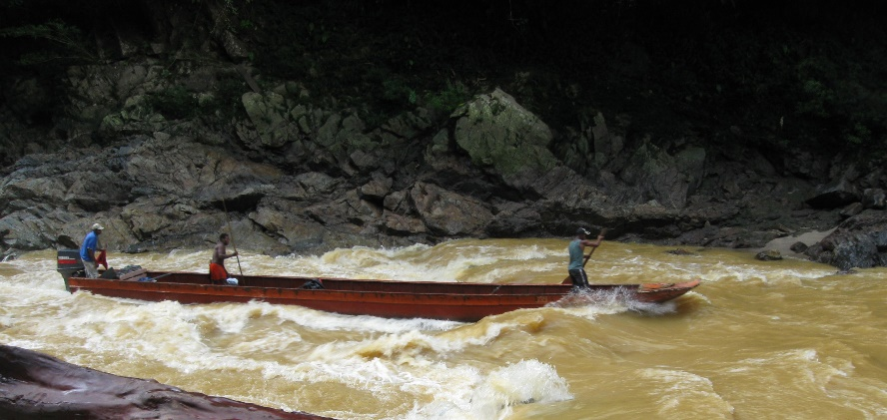
Picture 1. Access through river rapids to the Porce River
In the early 2000´s most migration to the area was promoted by a sense of opportunity at a high stake. The possibility of quick improvement of economic conditions through illegal plantations as well as illegal gold mining was the only way to improve substandard conditions for several migrants and locals.
The area has been historically known for being a drug trafficking corridor, managed by illegal armed groups who controlled not only access but all movement within the area, at least two different armed groups controlled the territory. On the other hand the production from illegal gold mining generated other type of stakeholders and other type of control. Gold miners, in precarious conditions risked their lives in a gold rush frenzy. The gold commercial chain was controlled by armed groups. Even though risky for some, the return could often be substantial.
As in other rural remote areas in Colombia the institutional capacity is limited and often influenced by political maneuvers as well as particular interest. Governance and institutional presence is lacking in many areas, control of such areas is performed by others, armed groups, local leaders responding to bigger and powerful groups, among others. The Porce River basin was not an exception during the first decade of the century, even to date.
Yet another important condition for the Porce River basin was the construction and operation of other hydropower projects (Porce II under operation since the year 1999 and Porce III which entered operation in late 2011). Reality, stories and myths around compensations offered by the project developers to affected peasants, miners and land owners among others generated speculation and for some represented yet another reason why migrating to the Porce IV project site was attractive.
In the year 2007 the engineering and environmental studies were developed for the Porce IV hydropower project. By 2010, environmental license was granted to build the project. For over more than 2 years detailed environmental and social studies were developed, numerous activities were carefully designed and undertaken. One of the first activities consisted of the socio-economic census to determine the social and economic characteristics of the population that lived in the projects area of influence. Families and communities were identified, as well as their conditions, economic activities, land ownership, social dynamics among others. During the next months a massive migration towards the area was observed. Initially, it was determined that 110 affected families by the Project and reservoir were to be part of an ambitious resettlement and compensation program (economic activities, housing, livelihood, etc.).
Over the next few years, while the environmental, social and engineering studies were finished and the environmental licensing process unfold the territory lived a time lapse of uncertainty and speculation. Thousands of families migrated to the Project area, rented, in some cases, few square meters and built huts in order to receive compensation. In the Chispero area, where initially a single family lived and managed a local goods shop, thousands established some sort of residence. Along with the migration side businesses also arrived, these provided all sorts of goods and services, a town was developed on the cliffs of the river canyon with all of its social dynamics and conflicts. There was a mix of interests, some had migrated due to the gold rush or the illicit plantation and coca leave traffic while most were attracted by the expectation of being included in the census and ultimately receiving some type of compensation.
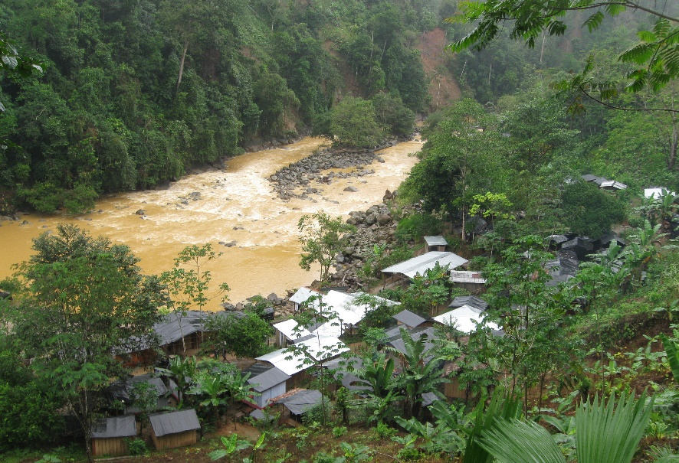
Picture 2. Migration to the Chispero territory
Individuals and leaders also saw an opportunity. Mobilized people were grouped by local leaders and in some cases guaranteed compensation by the project developer at a monthly fee. Leaders intended to negotiate with the project developer, thus increasing the already high speculation. Leaders spoke of up to fourteen thousand people that would be affected, thus could ultimately claim some type of compensation.
Speculation did not only come from the number of affected people who claimed lived in the area of influence, but also from miners who claimed had to be compensated for the mining rights over the resources that would be impounded by the reservoir. Hundreds of miners had migrated as well, dredges and excavators were a more common site on the river. The most precarious conditions existed; miners risked their lives constantly in a competition for a spot on the river.
An uncontrollable regional speculation chain developed, resulting in over ten thousand people migrating and invading Project areas, a wide range of social and public problems along with detriment of living conditions for locals. Despite these conditions a clear opposition to the project was not perceived, most likely due to the fact that most stakeholders were expecting a high compensation when the project started construction.

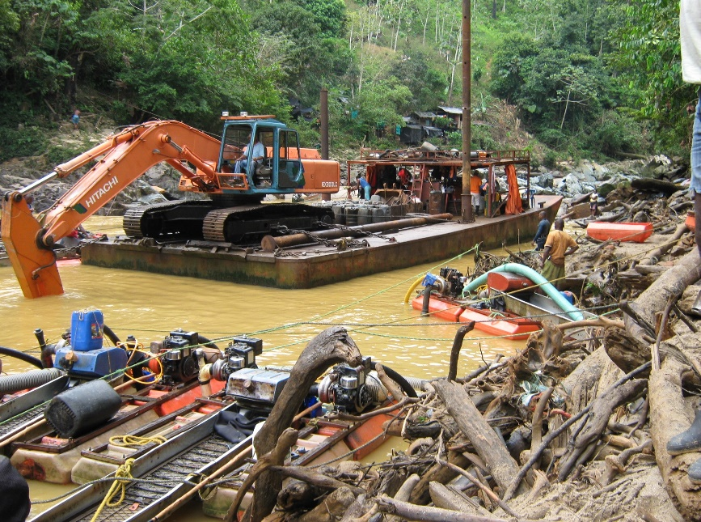
Picture 2. Pontoons and dredges mining alluvial gold
Ultimately, in late 2010, the Project developer decided to halt the construction phase of the Project mainly because the costs related to the compensation of over 14.000 people were not manageable; neither costs related to land acquisition of mining rights.
Conclusions
While conditions vary along the development phases of a Project, there is an implicit responsibility of understanding the territory, social dynamics, and cultural, economic and environmental conditions in order to manage expectations.
Among other several projects where INGETEC has provided environmental and social consultancy along Colombia, most in complex contests, lessons learned have been accumulated and documented. Actions plans have been and implemented specifically focused on managing expectations of local forces and stakeholder. It has been proven that those projects that have implemented assertive communications program, interinstitutional collaboration, community engagement and a continuous reality check have been more successful in managing stakeholders than those that don´t.
It has been recognized that a first and important effort is needed in order to understand local social, political, economic and environmental characteristics, as well as an effort to establish stakeholder mapping and strategic relationships which will eventually help monitor social dynamics. This effort will provide the basis for the design of a strategic “project entry plan” which should involve stakeholder engagement as well a robust communications strategy. A second long term effort is needed to implement such plan as well as a relationship strengthening strategy. A considerable effort is needed at the preconstruction phase in order to manage expectations at a local and regional level aiming at both preventing preconstruction phase impacts as well as preparing the road for the project´s construction phase. An equilibrium needs to be reached where expectations are kept low, however enough to motivate stakeholders and groups of interest.
Expectations are result of human nature and will happen, it is a matter of how well a Project can anticipate the unforeseen and quantify the unknown in order to better control the outcome its own promotion and actions.

